F.13 -

Functionality
Automatic clearing allows you to clear many vendor accounts in one transaction run. You can use a test mode to check your entries before posting takes place.
The items to be cleared cannot trigger a posting, for example, cash discounts or exchange rate differences.
You can also clean special G/L transactions, but only posted on Credit side.
In customizing you can define up to three fields that are treated by the system as the sort criteria for clearing. For instance, you can decide that all the documents with the same value in the field “Assignment” can be cleared.

Scenario
You want to send balance confirmations to vendors, so you need to clear open items on vendor accounts first.

Requirements
The accounts that can be cleared automatically must be defined in Customizing for Financial Accounting.

Menu Path | Accounting → Financial Accounting → Accounts Payable → Periodic processing → F.13 - Automatic clearing
Transaction Code | F.13
1. Double-click on F.13 - Automatic clearing

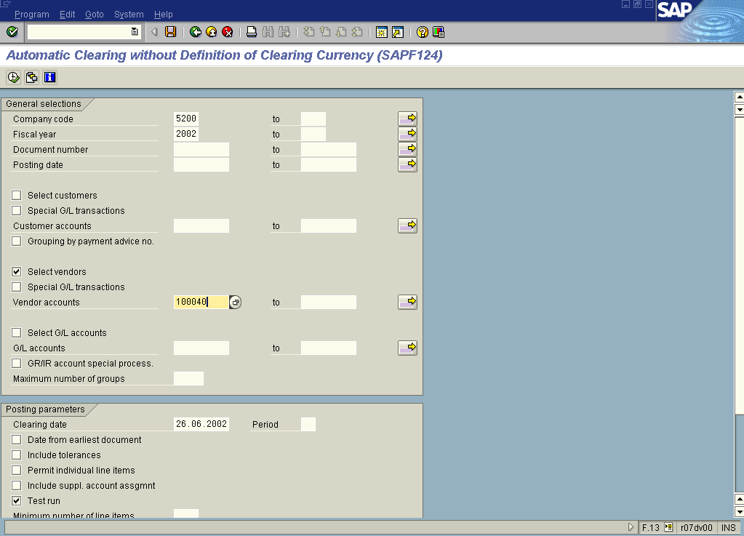

2. Update the following fields:

Field Name | Field Description | Values
Company code | Code identifying a separate legal entity for which a separate set of accounts is maintained for external reporting purposes | Example: 5200
Fiscal year | Fiscal year number | Example: 2002

3. Now click Select Button . You want to process only vendor accounts, so DO NOT SELECT other types of accounts.

4. Now enter the account number. You can enter a range of accounts (usual setting). In this example to simplify presentation only one vendor account is selected:

Field Name | Field Description | Values
Vendor accounts | Number of vendor account | Example: 1000040

5. Click Enter .
6. At the bottom of the screen (you need to use a mouse to scroll the screen down) there’s another radio button you need to select. Click Only docs which can be cleared . This way the system will clear only the documents that fulfill pre-defined clearing criteria (e.g. like the same assignment number).
7. By default the system is in the test mode. Click Test run button to turn it off.

8. You entered the selection criteria. Click Execute Button to begin clearing procedure.

Automatic Clearing without Definition of Clearing Currency (SAPF124)

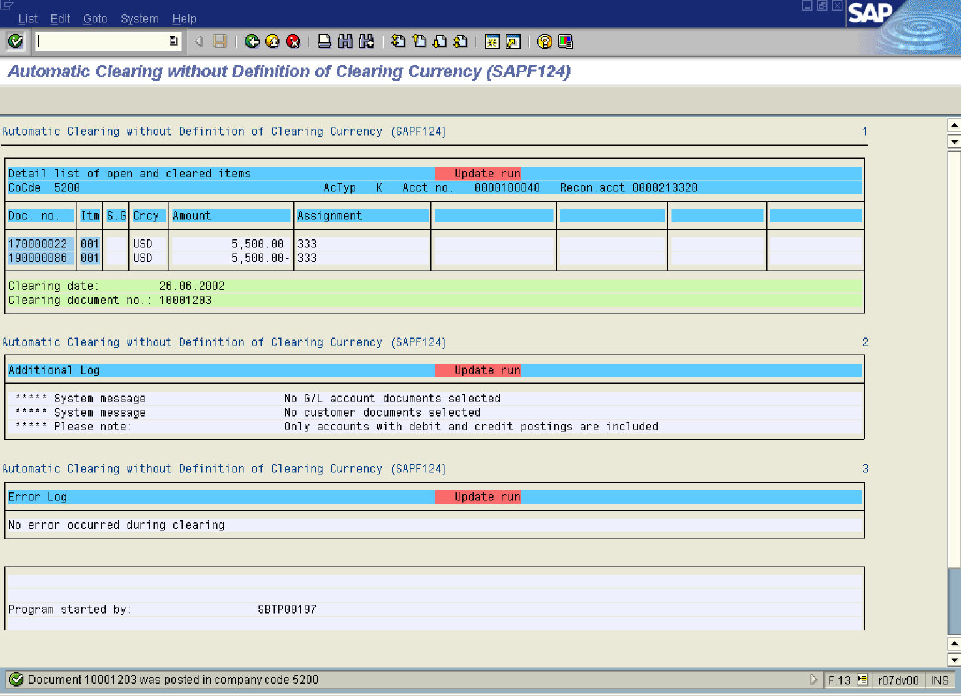

9. The message bar displays “Document number “xxxxxxx was posted in company code 5200”.

 This is the clearing document number. No real posting took place.

